Computer Workshop 7: Linear models with a multiple predictors
Roos & Pinard
Last updated: 2024-10-03
Table of Contents

Workshop Structure
As always, we’re using our tried-and-tested workflow to guide today’s workshop:
- Formulate a research question.
- Perform exploratory data analysis (EDA).
- Identify any hidden assumptions.
- Fit an appropriate model [today’s main focus].
- Diagnose the model and check assumptions.
- Summarise the results.
- Interpret and draw conclusions.

A Slight Tweak to Our Workflow
Today, we’re going to explore two different approaches to modelling using the same dataset with both models being fit using a linear model. You might recognize this dataset from the first week of the course — it contains information about rental prices in Aberdeen.
The two models we’re focusing on are:
- A predictive model aimed at predicting rent prices as accurately as possible.
- A causal model designed to understand the effect of square meters on rent price.
This exercise will show that the same statistical tools can be used for different goals — whether you want to build a simple predictive “AI” model or explore causal relationships.

Predictive Modelling
Predictive models are a great starting point when considering models with multiple explanatory variables because they’re usually more straightforward — no need to worry about tricky causal assumptions here (don’t tell the Machine Learning folks I said that!).

1. Formulate a Research Question
This one’s simple: We just want to predict rent price. We’re not interested in why a rented property (either a flat or house) is more or less expensive; we just want to predict the listed price as accurately as possible.

2. Perform Exploratory Data Analysis (EDA)
As usual, spend a few minutes exploring the dataset. Check for any obvious errors or odd values. Since you have a link to each property, you can even verify unusual entries yourself; a rare luxury in science!
As a warning, there are properties that when listed were given a specific price but by the time you look at a particular link, it may have had it’s priced reduced. For example, there is one property that when I first added it to the dataset was listed at a whopping £3,200 a month but at the time of writing this, that price had dropped to £2,900 (because no one was willing to pay £3.2k in rent). In these cases, you’ll need to decide for yourself how you want to deal with these. Your options are; 1) retain the original price if you think it wasn’t a data entry mistake, 2) update the price with the newly lowered rent, or 3) create an entirely new observation for this “new” listing. Note that option 3) will lead to an assumption being violated. Do you know which assumption would be broken if creating a new observation for any properties that had their price lowered?

3. Identify Any Hidden Assumptions
Even in a predictive model, we need to think about potential hidden assumptions. If our data is flawed or not representative, our predictions will be flawed too. Take a moment to consider limitations. For example, can we use this model to predict rent prices in London?
Another hidden aspect of the data that you may want to consider (and potentially resolve if you are unhappy with it), is that the data contains both rental prices for both houses and flats, with no distinction made between them. Unless you decide to go through all nrow(abdn) properties and classify them as house or flat, I’d suggest you leave this distinction out of the data. But if we do so, what do you think this lack of distinction will do in our predictive model?

4. Fit an Appropriate Model
One reason predictive modelling is so accessible is that we can throw all of our (sensible) explanatory variables into the model without worrying too much about the underlying relationships (obviously, we wouldn’t include the hyperlink as an explanatory variable in the model). But let’s keep it simple today. We’ll include the following predictors:
- sqmt: Property size in square meters.
- rooms: Total number of rooms (the sum of bedrooms and living rooms).
- epc: The property’s energy performance rating (categorical with levels A to G, A being the most energy efficient).
- tax: The council tax band based on the assumed property value in 1991 (categorical with levels A to G, G being the most expensive).
Notice that we’re using rooms in the model, but this variable isn’t in the dataset. You’ll need to create it by adding beds and living together (i.e., bedrooms and living rooms).
Another thing to note in this dataset are the epc and tax variables. In both of these variables, the underlying “values” are continuous (e.g. the property was worth £100,000 in 1991) but these have been discretised, or converted into groups (e.g. instead of £100,000 it’s recorded as tax equal to a).
Whenever this discretisation is done, when it comes to the actual model, it can make our life pretty horrible, which you can see when we write out the full notation. In our case, here’s what our model looks like:
$price_{i}∼Normal\left(μ_{i},σ\right)$
$μ_{i}=β_{0}+β_{1}×sqmt_{i}+β_{2}×rooms_{i}+β_{3}×epcC_{i}+$ $β_{4}×epcD_{i}+β_{5}×epcE_{i}+β_{6}×epcF_{i}+β_{7}×epcG_{i}+$ $β_{8}×taxB_{i}+β_{9}×taxC_{i}+β_{10}×taxD_{i}+$ $β_{11}×taxE_{i}+β_{12}×taxF_{i}+β_{13}×taxG_{i}$
Where:
- $β_{0}$ is the intercept, representing a property with zero square meters, zero rooms, an EPC of B, and a tax band of A.
- $β_{1}$ is the slope for each additional square meter.
- $β_{2}$ is the slope for each additional room.
- $β_{3,...,7}$ are the effects of each EPC rating compared to B.
- $β_{8,...,13}$ are the effects of each tax band compared to A.
As you can see, epc and tax being recorded as categories has made our model stupidly and crazily more complicated than it would otherwise be. If EPC and tax were continuous variables, we’d need to estimate just four parameters instead of 14!
A general tip: avoid creating categorical variables out of continuous ones when possible — it’ll save you headaches down the road (and often makes your analyses more reliable).
Despite the complexity, running this model in R is straightforward:
rent_mod <- lm(price ~ sqmt + rooms + epc + tax, data = abdn)
Now let’s take a look at the estimated parameters using summary():
summary(rent_mod)
##
## Call:
## lm(formula = price ~ sqmt + rooms + epc + tax, data = abdn)
##
## Residuals:
## Min 1Q Median 3Q Max
## -622.33 -82.95 -4.81 53.88 910.43
##
## Coefficients:
## Estimate Std. Error t value Pr(>|t|)
## (Intercept) 329.24652 78.20799 4.210 4.69e-05 ***
## sqmt 0.09491 0.92824 0.102 0.918719
## rooms 175.11885 28.70803 6.100 1.10e-08 ***
## epcc -142.82581 55.11507 -2.591 0.010634 *
## epcd -223.23608 59.82399 -3.732 0.000282 ***
## epce -153.16867 74.49666 -2.056 0.041749 *
## epcf -198.65246 190.22361 -1.044 0.298251
## epcg -132.09400 125.92256 -1.049 0.296090
## taxb 60.57588 54.79286 1.106 0.270935
## taxc 67.29495 60.48214 1.113 0.267885
## taxd 33.30104 56.88932 0.585 0.559301
## taxe 285.90432 66.69695 4.287 3.47e-05 ***
## taxf 228.10775 87.27079 2.614 0.009994 **
## taxg 511.22725 131.94895 3.874 0.000168 ***
## ---
## Signif. codes: 0 '***' 0.001 '**' 0.01 '*' 0.05 '.' 0.1 ' ' 1
##
## Residual standard error: 182.4 on 132 degrees of freedom
## Multiple R-squared: 0.7909, Adjusted R-squared: 0.7703
## F-statistic: 38.41 on 13 and 132 DF, p-value: < 2.2e-16
This produces a giant list of estimated parameters; reminding us why it’s best to avoid excessive categorization. Keep this in mind for your future work (including your Honour’s project), both for simplicity and for more meaningful analyses!
The complication with predictive models is that these parameters estimates don’t have a “biological” or “real world” meaning. We wouldn’t read these as “increasing X causes Y to increase” by whatever the parameter value is. Instead it’s what the model would predict the increase would be. If that’s unclear the lecture slides on causal inference may help clarify.

5. Diagnose the model and check assumptions.
In previous workshops, we’ve saved assumption checks for the Friday session, but by now, you should be feeling more confident and able to do this more quickly.
Let’s run a quick diagnostic check:
par(mfrow = c(2,2))
plot(rent_mod)
## Warning: not plotting observations with leverage one:
## 88
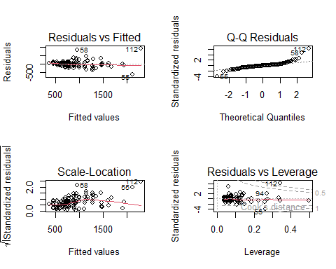
par(mfrow = c(1,1))

Question Set One
- Do you see any assumptions that are likely broken in the Residuals vs Fitted and Scale-Location plots?
- If so, what is the consequence of violating this assumptions?
- Do you see any assumptions that are likely broken in the Q-Q Residuals plot?
- Are there any observations that are having a disproportionate affect on the model?
- If there are any such observations, what should we do about them (if in doubt, ask a member of staff)?
Given your dataset may be slightly different to the one I used above (given how you dealt with any changes in listed price, houses versus flats, etc.), you may have seen some issues in the Residuals verses Leverage plot (though you may not, which would be fine). If you did see any problematic observations, before moving ahead, remove any observations from your dataset where the associated Cook’s distance was $≥1$ and rerun your model. As a hint, if I believed the flats on rows 1 and 2 of the dataset were causing issues in the model, I could remove them by doing (observations 1 and 2 chosen here at random just to demonstrate how to remove them):
abdn <- abdn[-c(1, 2),]
The - before c() basically means “remove”, so here we’re removing rows 1 and 2 (remember that square brackets are organised as [row,column]).
Having removed these and rerun the model (unless your previous checks suggested no issues and you did not need to remove any observations). Do a quick check of the diagnostic plots to see if this has resolved the issue.
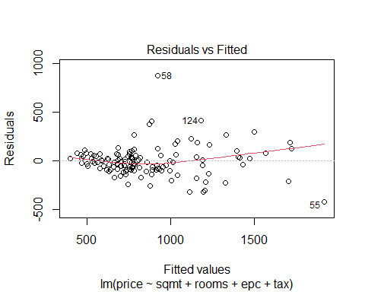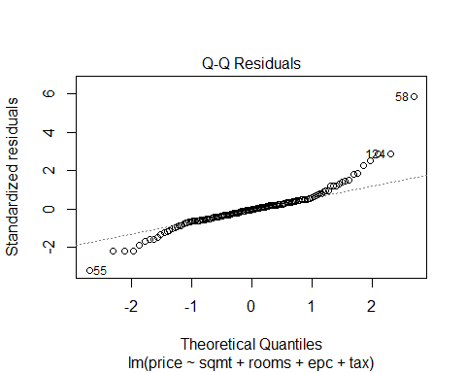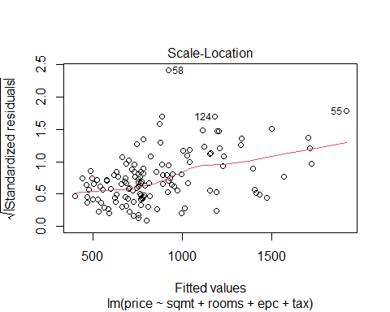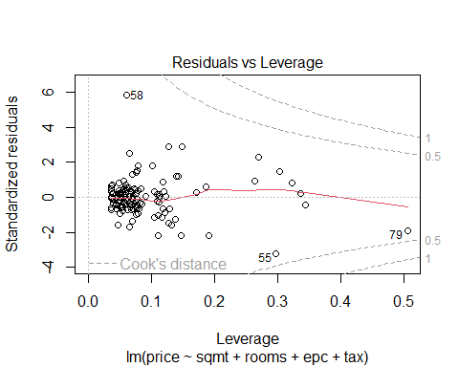
Hopefully removing those observations has resolved the disproportionately influential observations. There’s some important nuance about removing observations from a dataset. For details on this, see the answer sheet for question 5 above.

6. Summarise the results.
As usual, pull up the summary table:
summary(rent_mod)
##
## Call:
## lm(formula = price ~ sqmt + rooms + epc + tax, data = abdn_trimmed)
##
## Residuals:
## Min 1Q Median 3Q Max
## -416.16 -74.58 -5.99 53.42 876.46
##
## Coefficients:
## Estimate Std. Error t value Pr(>|t|)
## (Intercept) 405.4371 67.1331 6.039 1.50e-08 ***
## sqmt 2.3428 0.8458 2.770 0.006421 **
## rooms 96.1799 26.6606 3.608 0.000438 ***
## epcc -138.5112 46.7317 -2.964 0.003609 **
## epcd -205.0530 50.7821 -4.038 9.13e-05 ***
## epce -147.2898 63.1653 -2.332 0.021236 *
## epcg -166.7224 106.8668 -1.560 0.121150
## taxb 58.7017 46.4554 1.264 0.208613
## taxc 72.6919 51.2836 1.417 0.158726
## taxd 56.1083 48.3345 1.161 0.247820
## taxe 275.7660 56.5645 4.875 3.09e-06 ***
## taxf 270.0039 74.2153 3.638 0.000394 ***
## taxg 294.1042 115.8032 2.540 0.012263 *
## ---
## Signif. codes: 0 '***' 0.001 '**' 0.01 '*' 0.05 '.' 0.1 ' ' 1
##
## Residual standard error: 154.6 on 131 degrees of freedom
## Multiple R-squared: 0.798, Adjusted R-squared: 0.7795
## F-statistic: 43.12 on 12 and 131 DF, p-value: < 2.2e-16
Pay attention to the Estimate for sqmt; the model seems to be predicting that adding an extra 1 square meter to a property only increases the rent by about £2.34. Seems a bit low, right? Do we really think that the difference in price between a 50 m$​^{2}$ flat and a 100 m$​^{2}$ flat will be just £117 extra per month? We’ll come back to this after we run the causal version of this model.
Given the number of explanatory variables we have in our predictive model, we’ll use ggeffects to do the plotting, though you can definitely do this manually if you prefer more control (see the instructions with answers to see how to do that).
library(ggeffects)
## Warning: package 'ggeffects' was built under R version 4.3.3
Then ask ggeffects to show the predicted relationship (or association) between rent price and each of our explanatory variables:
preds <- ggpredict(rent_mod)
## Warning: Some of the focal terms are of type `character`. This may lead to
## unexpected results. It is recommended to convert these variables to
## factors before fitting the model.
## The following variables in are of type character: `epc`
## Warning: Some of the focal terms are of type `character`. This may lead to
## unexpected results. It is recommended to convert these variables to
## factors before fitting the model.
## The following variables in are of type character: `tax`
Now we just need to plot it (note you may need to press the blue arrow buttons in the Plots pane in RStudio to page through the different figures):
plot(preds)
## $sqmt
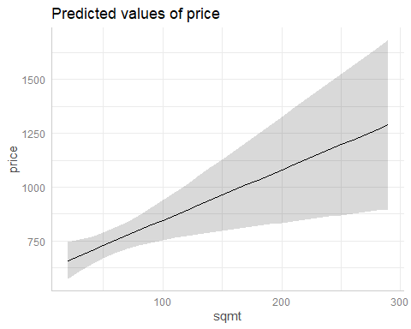
##
## $rooms
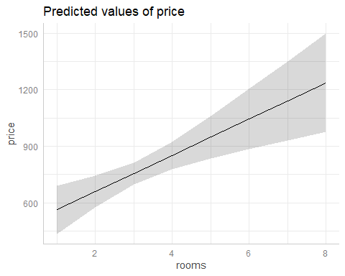
##
## $epc
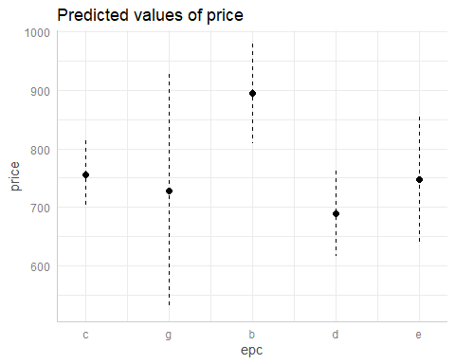
##
## $tax
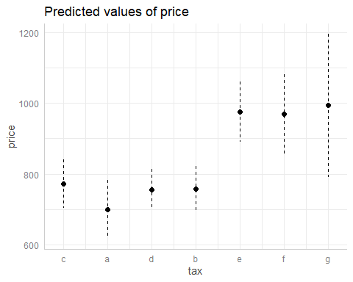
We get the same message that we saw previously, where ggeffects isn’t terribly happy using strings that are recorded as characters rather than factors. If you want to appease ggeffects, feel free to convert your categorical variables to factors and rerun your analysis.

Question Set Five
- Can we identify any causal relationships from this model (e.g. “If you increase the square meters of a property by 10 meters squared, it will cause the rent to increase by X”)?
- Why might the relationship between price and sqmt be smaller than we’d expect?
- Go to the letting agency website, ASPC, and find a recently listed rental property which has all of the explanatory variables you need. Using your selected property, see how well your model predicts the rent. You’re also welcome to use your own flat if you know (or can guess) how many square meters it has, what the EPC rating is, and which tax band it falls in.
If you want to see how this kind of model could be translated into something you might see online with some marketing saying something like “We’re using the most advanced Generative Artificial Intelligence to predict how much rent you should be asking for”, see here. This is a little toy website I made (entirely in R). There are two important things to note; 1) I think there’s a decent chance the website will crash if lots of people try to use it at the same time, and 2) I include another model that deals with space - i.e. certain areas in Aberdeen are more expensive than others. One assumption we’re likely to break here is the assumption of independent errors, and including space in the model helps to account for that (this is the “Fancy model” on the site).

Causal Modelling
Having run a model that aims to predict rent price, we’re now going to switch over to causal modelling using the same dataset. Hopefully the differences and similarities between the two approaches will become clear.
To be responsible, be sure to re-load the data again, so that any changes we made to it specifically for the predictive modelling are not carried into our new analysis. However, if there were any issues that you previously resolved, do so again now.

1. Formulate a Research Question
Our research question is going to be to understand the causal effect of square meters on rent price, or “How much would rent be if a property were larger or smaller?”. The important thing here is that we’re going to try and and ask a causal question and not simply exploit associations (i.e. correlations) to make accurate predictions.
Because we’ve already carried out an EDA and thought about hidden assumptions with regards to this data, we can skip these steps but before we get to fitting the model, we have an extra step when we want a model to potentially understand causation.

Extra: Creating a DAG
Because our question is causal, we can’t just use the approach we did above and throw everything into the model and read off every parameter estimate as being causal (a practice that is called the “Type 2 Fallacy”, so named because the second table of a paper often contains parameter estimates, which authors may then read as being causal). Instead, we need to think about confounding and how to responsibly deal with that in our model. One of the least technical ways of doing this (but not the only way) is to create a Directed Acylic Graph (or DAG) and use this in combination with the Backdoor Criterion to inform which explanatory variables should, could or should not be included in the model to understand the causal effect of interest. This process of drawing a DAG can sometimes be intellectually challenging (e.g. does the square meters of a property cause the number of rooms, or is it the number of rooms that cause the square meters?) and is often be a pretty laborious process. The intellectual challenge in drawing a DAG is one of the big downsides (and a good argument to use experiments when possible when trying to determine causation), but just drawing the DAGS can be a real pain especially if you create your DAG in PowerPoint. Thankfully there’s a much easier way to do this in R using the package we’ve used previously - performance.
However, a slight complication is that we’re using a “developer” version of performance that hasn’t yet been put onto CRAN (the central repository where R packages are kept), so we’ll need to install the package directly from the developers. To do so, we’ll need to do a minor tweak to our install.packages() code where we say where the version is available from. At the same time, we’ll need to download an extra package called see from the same developers, which works with performance on some things in the background.
To install the correct version of performance re-install it by running:
install.packages(c("performance", "see"), repos = "https://easystats.r-universe.dev")
In R, the function check_dag() from the performance and see packages helps us create and evaluate a DAG. Here’s how it works:
- Specify the Causal Relationships for the Response Variable:
- You need to outline what you believe the causal relationships are. For example, if you think rent is influenced by the number of rooms, square meters, tax band, and EPC, you would “translate” this to Rent ~ Rooms + Sqmt + Tax + EPC. Note that the variable names in the model don’t have to match those in your dataset; just avoid using spaces in variable names, e.g., use Aberdeen_Rent instead of Aberdeen Rent.
- Define the Relationships Between Variables:
- Having done that, we now just go through what might cause our explanatory variables, for example the number of rooms you can have in a flat is must surely be caused by how many square meters there are, so we include this as: Rooms ~ Sqmt, and so on for the other explanatory variables.
- Set Up the Response and Explanatory Variables:
- The final part we need to complete is to define what our response variable is (called “outcome” by performance) and what our explanatory variable is (called “exposure”). This defines our initial and simple model, which in this case would be: Rent ~ Sqmt.
Here’s what your code might look like (but note that your DAG might look different from mine, e.g. maybe you don’t agree with me that EPC is caused by the size of a property):
library(performance)
## Warning: package 'performance' was built under R version 4.3.3
library(see)
## Warning: package 'see' was built under R version 4.3.3
rent_dag <- check_dag(
price ~ rooms + sqmt + tax + epc,
rooms ~ sqmt,
epc ~ sqmt,
tax ~ sqmt,
exposure = "sqmt",
outcome = "price"
)
Once we’re happy that we have a DAG that seems sensible, we can then plot it:
plot(rent_dag)
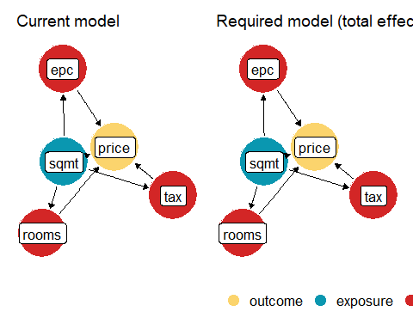
Note that the exact positions of the variables in the figure are semi-random, so your figure might not look exactly the same as mine, e.g. sqmt might be on the right instead of the left of tax but the arrow should still go from sqmt to tax.
The left hand figure shows the version of the DAG if we ran the model:
lm(price ~ sqmt, data = abdn)
while the figure on the right shows the version of the DAG that would required if we wanted to understand the total causal effect that changing sqmt would have on the price. In this case, they look identical? Why is that? Well, note that sqmt drives a lot of causal relationships in our DAG: sqmt → rooms → price, and sqmt → tax → price, etc. So according to this DAG, if a landlord increased the square meters of their property it will have lots of “knock on” effects, e.g. increasing sqmt will increase how many rooms you have, resulting in a higher listing price. These are all “piped confounds” (sometimes called “mediators”). Remember the example of what to do with pipes? We normally want information to “flow”, so we don’t “block” them. Here we keep them “unblocked” by not including the respective explanatory variable.
The reason for doing so here is that all of these ways in which changing sqmt will cause a change in price are relevant to understanding the total causal effects of changing sqmt. If we’ve increased the square meters of a property, and that results in an extra room, isn’t that part of how sqmt causes a price change? So in this case, the model we want to run, to identify the total causal effect that changing sqmt would have on the price is:
lm(price ~ sqmt, data = abdn)
Note that it won’t always work out that to understand the causal effect of X on Y requires the model Y ~ X. In fact, most of the time it doesn’t. It’s just that according to this particular DAG, to understand sqmt on price we would run the model price ~ sqmt.
For a slightly more detailed summary of the DAG, we can simply pull up the DAG object in R to use it to identify which model we should run to answer our research question:
rent_dag
## # Check for correct adjustment sets
## - Outcome: price
## - Exposure: sqmt
##
## Identification of direct effects
##
## Incorrectly adjusted!
## To estimate the direct effect, at least adjust for `epc`, `rooms` and `tax`.
## Currently, the model does not adjust for any variables.
##
## Identification of total effects
##
## Model is correctly specified.
## No adjustment needed to estimate the total effect of `sqmt` on `price`.
We get two pieces of information here
This tells us that to estimate for the direct effect of sqmt on price, we would also need to include EPC and Rooms, but we aren’t interested in just the direct effect. For clarity, the direct effect would be the effect of adding extra square meters to a property not including the fact that this will likely influence the number of rooms, the EPC, the tax band, etc. Instead, based on our research question we want to understand what would happen to price if we increased a property by, say, 10 square meters, and all the different ways those extra 10 m result in a change in price. So we want the total effects. For that, check_dag() has suggested that the initial model is correctly specified, where our initial model was price ~ sqmt.

4. Fit an appropriate model.
Let’s run that model:
rent_causal_mod <- lm(price ~ sqmt, data = abdn)

5. Diagnose the model and check assumptions.
And we can do a quick check of the assumptions related to the model residuals:
par(mfrow = c(2,2))
plot(rent_causal_mod)
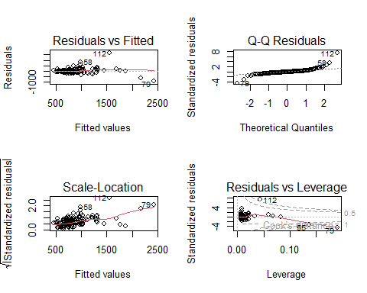
par(mfrow = c(1,1))
Most of the diagnostics look ok. Not great, but maybe just about good enough to work with, with the exception of the Residuals vs Leverage plot.
As for the predictive model, decide how you want to deal with the Residuals vs Leverage plot and rerun your analysis if necessary.

6. Summarise the results.
The technical steps are exactly the same as for the predictive model. Get the model summary:
summary(rent_causal_mod)
##
## Call:
## lm(formula = price ~ sqmt, data = abdn_trimmed)
##
## Residuals:
## Min 1Q Median 3Q Max
## -407.05 -68.75 -10.51 67.35 793.52
##
## Coefficients:
## Estimate Std. Error t value Pr(>|t|)
## (Intercept) 231.1144 31.7002 7.291 2.02e-11 ***
## sqmt 8.5205 0.4037 21.104 < 2e-16 ***
## ---
## Signif. codes: 0 '***' 0.001 '**' 0.01 '*' 0.05 '.' 0.1 ' ' 1
##
## Residual standard error: 158 on 141 degrees of freedom
## Multiple R-squared: 0.7595, Adjusted R-squared: 0.7578
## F-statistic: 445.4 on 1 and 141 DF, p-value: < 2.2e-16
And plot:
fake <- data.frame(
sqmt = seq(from = min(abdn$sqmt), to = max(abdn$sqmt), length.out = 10)
)
preds <- predict(rent_causal_mod, newdata = fake, se.fit = TRUE)
fake$fit <- preds$fit
fake$low <- preds$fit - preds$se.fit * 1.96
fake$upp <- preds$fit + preds$se.fit * 1.96
ggplot(fake) +
geom_ribbon(aes(x = sqmt, ymin = low, ymax = upp), fill = "lightgrey", alpha = 0.7) +
geom_line(aes(x = sqmt, y = fit)) +
labs(x = "Square meters of property",
y = "Predicted rent") +
theme_bw()
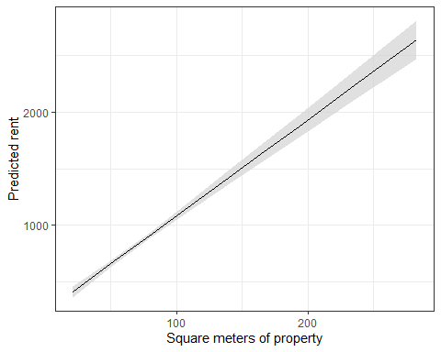
So what we learn is that for every additional meter square “added” the rent increases by roughly £8.50. So long as we assume that our DAG is accurate (a potentially big assumption), this £8.50 increase is the causal effect of square meters on rent.
Compare that with our predictive model that found “adding” an extra square meter to a property would increase the price by £2.30. At the time, we noted that £2.30 seemed on the “cheap” side and the reason for the predictive modelling estimating it as being “cheap” was because, according to out DAG, m$​^{2}$ was confounded by the number of rooms in a flat. To be clear, that confounding didn’t matter for the first model because our aim was to make predictions, not to understand the causal effect.

What is the causal effect of EPC on price?
Repeat the above process, but where our research question is focused on understanding the causal effect of EPC on price.
Because we’re doing a new analysis, be sure to re-load the data before proceeding.

Assumption table
Assumption | Description | Example of Violation
1. Validity | The data is able to answer the research question effectively. | Using IQ to measure overall intelligence (what does IQ even measure?).
2. Representativeness | The data reflects the population or group being studied. | Using survey data from a rural area to draw conclusions about an urban population.
3. Additivity | Effects of predictors are additive and there are no interactions between them. | Assuming that study hours and sleep hours independently affect exam scores without considering their combined effect (imagine a Venn diagram with study and sleep overlapping).
4. Linearity | The relationship between predictors and the outcome is linear. | Assuming plant growth will continue to increase indefinitely without ever levelling out.
5. Independence of Errors | Observations are independent of each other. (Related to residual errors.) | If modelling height, the data come from the same group of children over time.
6. Equal Variance of Errors | Residuals have constant variance across all levels of predictors (“homoscedasticity”). (Related to residual errors.) | If modelling income, variability in salaries is not the same across all levels of a company’s hierarchy.
7. Normality of Errors | Residuals should be normally distributed. (Related to residual errors.) | If modelling income, the presence of any extremely wealthy individuals will be hard for the model to understand and explain.

